**Overview**

A simplified version of the original concept for LifeSavers. The Fitness and Mental aspects of the game on any given character.

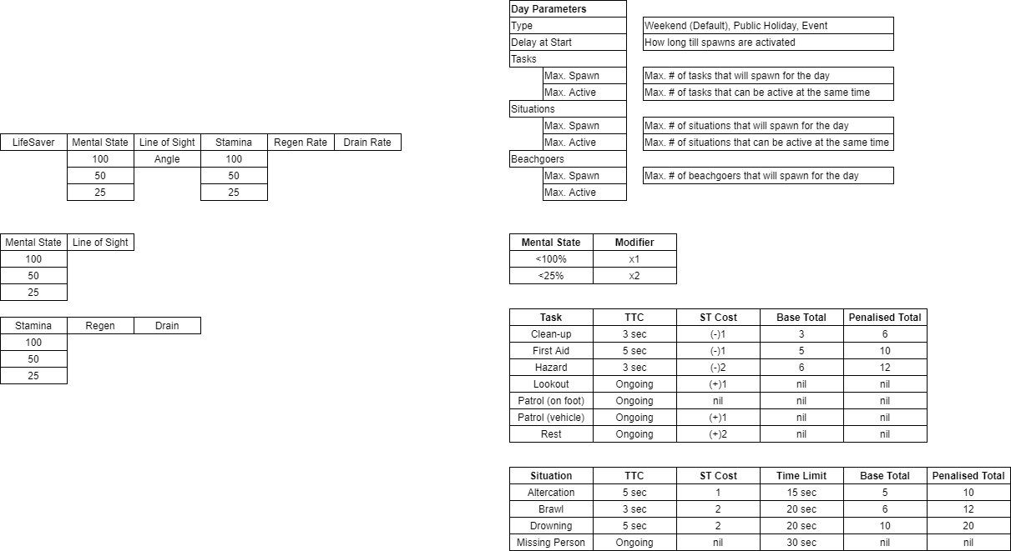

Label what the abbreviations are meant to be, not sure if it was just an issue on my own end but I was really struggling to parse any of this at all until I worked out what some of these were and even now I am unsure about whether I entirely grasp a lot of it. Brief definitions of some of these terms would be helpful to have on the diagram so it’s easier to understand at a glance .

**The Economy**

Tasks performed by volunteers has a Fitness / Mental cost, this will reduce their overall effectiveness by the end of the day and carries unto the next day if the volunteer is not taken off the roster for rest.

All volunteers start at 100% on their Mental and Fitness meter from day one and it is reduced as tasks are performed and tallied by the end of the day.

The example shows one volunteer on full rotation without a break for 3 days.

After each day, the average success rate is reduced by the total of the FC and MC and affects the success percentage for the next day.